**Exercise: Configuring a Flat schema**

**Introduction**

At this stage of the course, you should now have a good understanding of three data models commonly used for data analysis in Power BI.

In this exercise, you can apply your knowledge of these data models to configure the Flat schema.

* You will walk through the steps to create a Flat schema in Power BI using the example of an online bicycle store called Adventure Works.
* You'll demonstrate how the store uses a schema to consolidate and analyze data, leading to better business decisions.

**Scenario**

Adventure Works has seen a rise in customer complaints following incorrect and delayed deliveries. The company suspects inconsistencies in its data have caused the issues.

To fix these issues, Adventure Works needs to create a data model in Power BI that accurately and consistently organizes and integrates its data. You can help the company to develop this data model as a Flat schema.

The company provides you with an Excel file called *AdventureWorksDataSet*. The file consolidates all required data into a table containing all relevant fields related to the company’s products and orders.

You must load this dataset into Power BI and develop it as a Flat schema. Be sure to evaluate the data quality and configure the model to ensure that Adventure Works can use it to make informed decisions.

[AdventureWorksDataset](https://d3c33hcgiwev3.cloudfront.net/2g2nixOTQ-6p_5f5ufiLDA_0804f6aeacae44b99d0b44f28faa9be1_AdventureWorksDataset.xlsx?Expires=1709942400&Signature=bs29vcbiO8SifMLQvJVzbY7Zb1f0Vq9mUd0-PgYPkkjIvVGH6z4Wuc5MQrjg1rgnTqbTJ4Ymm~~7TUmLu5V5Tp-jEPSp4uJbNxMTAcGGgcUzfG6-IfkhnY1MPq8Z--mnHX3DDwzpFVVzgV-VvlN22rvlpE-Ejy91u0C7c-Crh9Q_&Key-Pair-Id=APKAJLTNE6QMUY6HBC5A" \t "_blank)

[XLSX File](https://d3c33hcgiwev3.cloudfront.net/2g2nixOTQ-6p_5f5ufiLDA_0804f6aeacae44b99d0b44f28faa9be1_AdventureWorksDataset.xlsx?Expires=1709942400&Signature=bs29vcbiO8SifMLQvJVzbY7Zb1f0Vq9mUd0-PgYPkkjIvVGH6z4Wuc5MQrjg1rgnTqbTJ4Ymm~~7TUmLu5V5Tp-jEPSp4uJbNxMTAcGGgcUzfG6-IfkhnY1MPq8Z--mnHX3DDwzpFVVzgV-VvlN22rvlpE-Ejy91u0C7c-Crh9Q_&Key-Pair-Id=APKAJLTNE6QMUY6HBC5A" \t "_blank)

**Instructions**

Create a new Power BI project called *Exercise-Configuring a Flat schema*. Follow the steps below to complete the exercise.

**Step 1: Download the Excel Files:**

* Download and open the Microsoft Excel workbook **AdventureWorksDataset.xlsx**. The workbook contains only one worksheet called **AdventureWorksData**.

**Tip:** You can download the workbook from this page by selecting the attached Excel file.

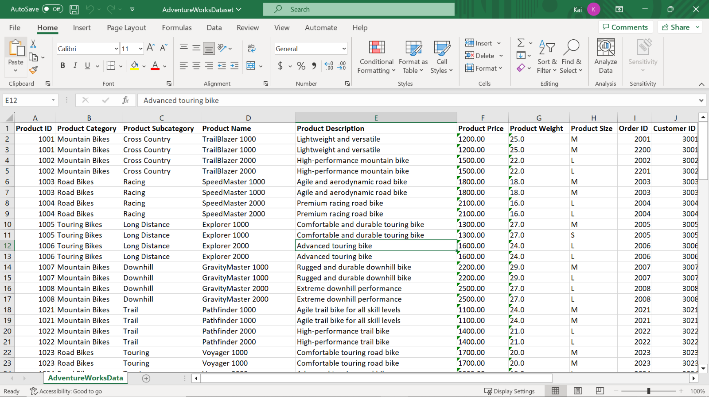

**Step 2: Connect to the Excel workbook and load the data into Power BI:**

1. Connect to the Excel spreadsheet in Power BI.
2. Select the table from the dataset and load it into the Power BI data model.
3. Open a preview of the table in the **Preview** pane.

**Tip:** You can import data using the **Get Data** drop-down menu.

**Step 3: Configure the table properties:**

1. Configure the table properties by renaming the table to **Product** and adding a brief description of the table in Power BI desktop.

**Tip:** You can configure table properties in the Power Query editor or the **Model view** of Power BI desktop.

**Step 4: Configure the column properties:**

1. **Order ID** should be a unique value for each sales order. It’s essential to eliminate all duplicate values in the column to generate accurate analytical results. Identify and remove all duplicate values in the **OrderID** column in the worksheet. Review the number of rows in the **Query Editor** to ensure all duplicate rows have been deleted.

**Tip:** You can remove duplicate values using the **Remove Duplicates** feature.

1. Format the data type of the **Product Price** column to **currency**.

**Tip:** You can configure column properties in the Power Query editor and the Model view of the Power BI desktop.

**Step 5: Save the Power BI Project**

1. Navigate to the **Model view** of the Power BI desktop and ensure that all required tables are present in the model.
2. Save your flat schema Power BI project to your local machine.

**Tip:** Select an appropriate project name and folder path for your schema.

**Conclusion**

It is important to note that while a Flat schema can be convenient for some scenarios, it may not be suitable for complex data relationships or larger datasets. In such cases, a normalized schema with multiple tables and defined relationships is a better option to ensure performance and flexibility.

# **Exemplar: Configuring a Flat schema**

**Overview**

In the exercise, *Configuring a Flat schema*, you were asked to put your knowledge of data modeling into practice by creating a Flat schema.

Your task in this exercise was to configure a Flat schema as follows:

* Connect Power BI to the data source.
* Load, transform, and shape the data as a Flat schema in Power BI desktop.
* Configure the Flat schema for simplified data analysis and visualization.

This reading provides you with a step-by-step guide for identifying these results. It also includes screenshots that you can compare against your work.

You can review the steps for configuring a Flat schema in the videos [*Introduction to data models*](https://www.coursera.org/learn/data-modeling-in-power-bi/lecture/hjIme/introduction-to-data-models), [*Introduction to schemas*](https://www.coursera.org/learn/data-modeling-in-power-bi/lecture/CryuH/introduction-to-schemas) and [*Setting up a Flat schema in Power BI*](https://www.coursera.org/learn/data-modeling-in-power-bi/lecture/gx5yP/setting-up-a-flat-schema-in-power-bi). You can also review the reading items [*Schemas cheat sheet*](https://www.coursera.org/learn/data-modeling-in-power-bi/supplement/IJw15/schemas-cheatsheet) and [*Table and column properties cheat sheet*](https://www.coursera.org/learn/data-modeling-in-power-bi/supplement/Mp5cd/table-and-column-properties-cheatsheet).

**Power BI Desktop user interface**

While reviewing this reading, you may see some changes in the Power BI user interface (UI) from what’s described in the following steps.

Power BI Desktop is updated and released monthly, incorporating customer feedback and new features. You might experience changes in the Power BI Desktop UI that have taken place after the development of this training content.

As a result, the screenshots in the videos, readings, or exercises might not align exactly with how you experience the UI. However, please note that these changes do not impact the functionalities of the UI. So you will still be able to perform all the steps shown in that video, reading, or exercise.

**Step 1: Download the Excel Files:**

1. Download and open the Microsoft Excel workbook **AdventureWorksDataset.xlsx**. The workbook contains one worksheet called **AdventureWorksData**, which includes information on the company’s sales.



**Step 2: Connect to the Excel workbook and load the data into Power BI:**

1. Launch the Power BI desktop and select **Get Data** to connect to the source.
2. Navigate to the folder containing the Adventure Works spreadsheet you downloaded.

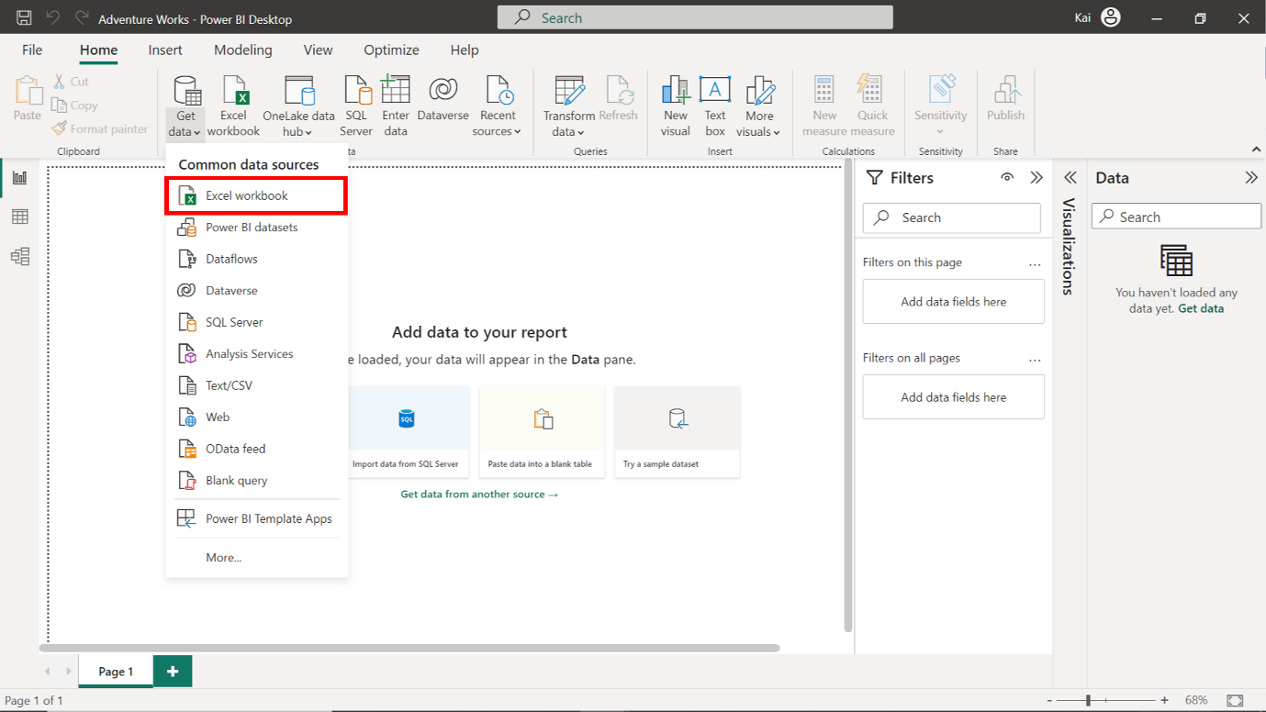

1. A navigator menu appears on the screen displaying a list of tables available within your dataset. In the navigator dropdown menu, select the **Adventure Works** dataset. Then select **Load**.

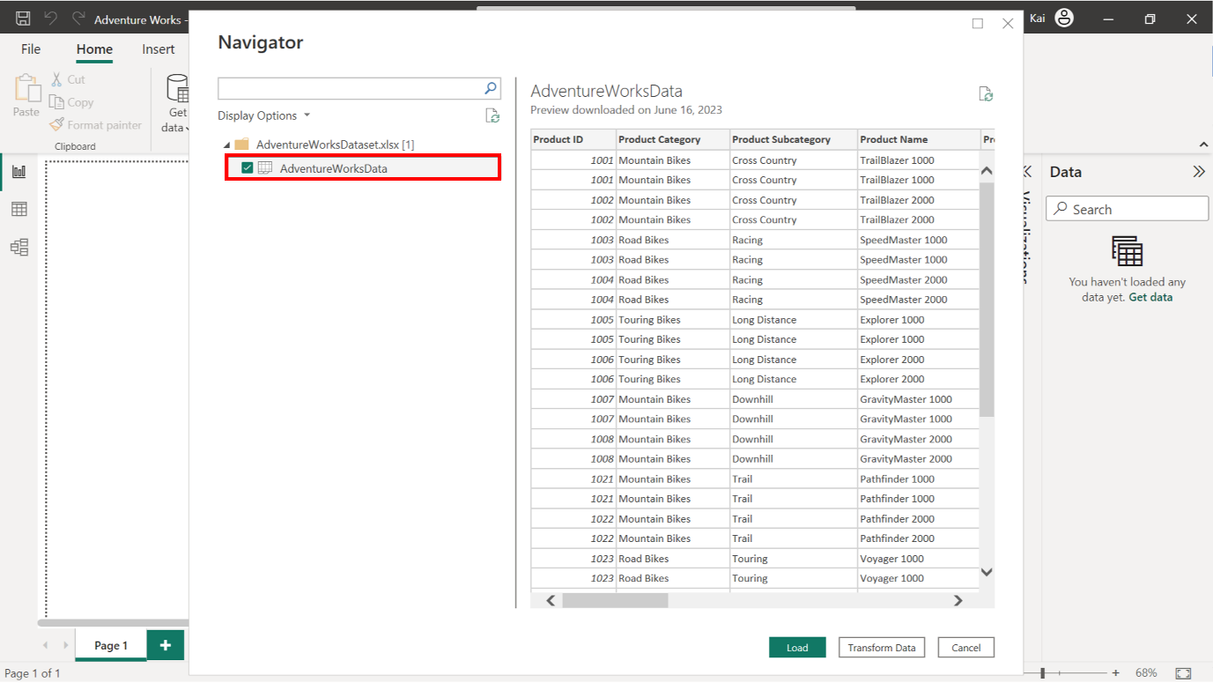

1. A preview of the dataset is visible in the preview pane.

**Step 3: Configure the table properties.**

1. Open the **Home** tab and select **Transform data** to open the **Power Query** editor.
2. Once in the **Power Query** editor, select **Properties** to open the **Query Properties** dialog box.
3. Change the table's name to **Product** and add a dataset description.

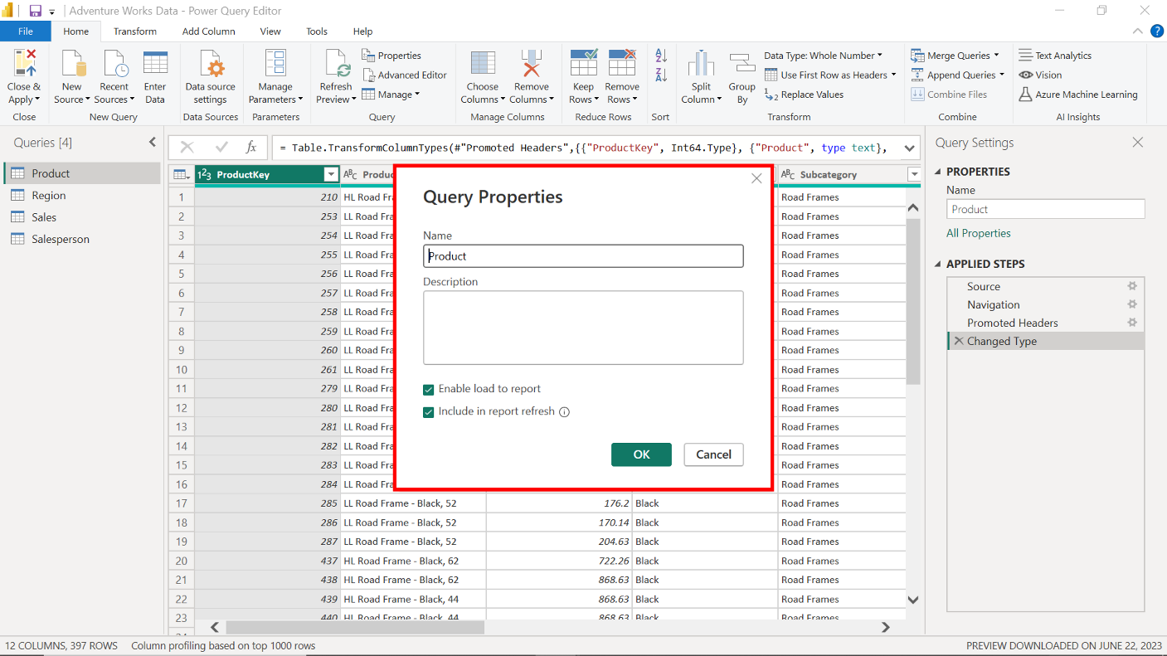

**Step 4: Configure Column Properties.**

1. In the **Home** tab of the query editor, select **Remove Rows**.
2. Select the **Remove duplicates** option from the dropdown menu.
3. Select the **Product Price** column.
4. Open the **Column Tools** tab in the Power BI desktop interface.
5. Navigate to the **formatting** group and select **Currency** from the dropdown menu. This action displays a **$** sign before the amount in the entire column.

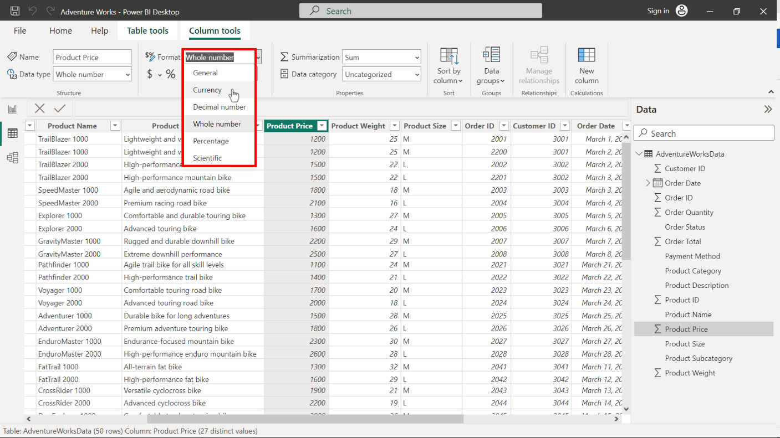

**Step 5: Evaluate the data model and save the Power BI project**

1. To view the dataset loaded to Power BI, select **Model View** from the left sidebar. The **Model view** should display only one table with all columns as data attributes. This is the typical structure of a Flat schema.
2. Adventure Works can now use this Flat schema to build visualizations, reports, and dashboards to draw insights into its business operations.

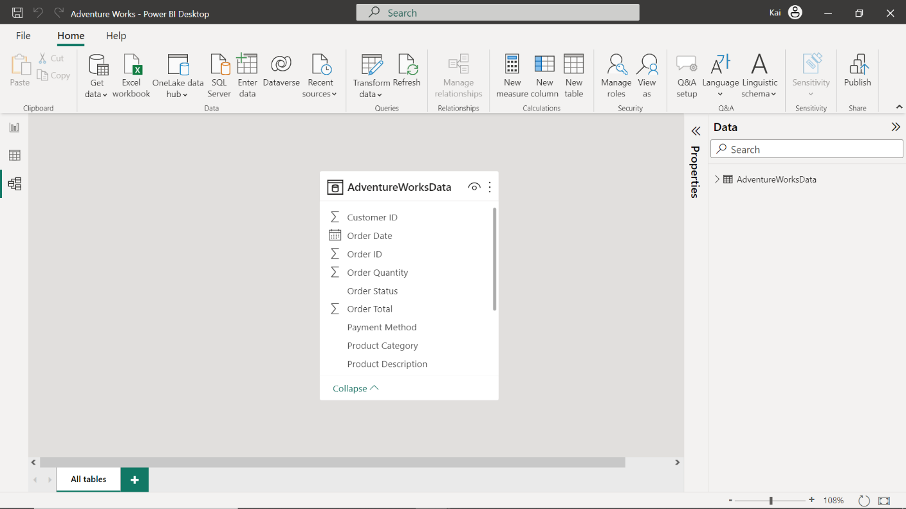

1. To save the project, access the **File** menu and select **Save As**. Provide an appropriate name for the project and a suitable path to the folder on your local machine.

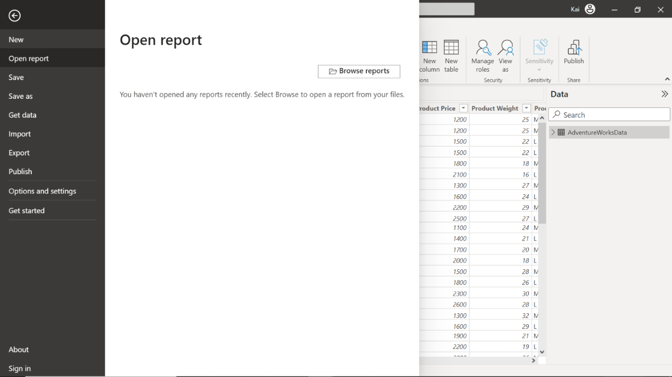

**Conclusion**

Congratulations! You have completed the exercise and configured the Adventure Works dataset as a Flat schema in Power BI. Your data model is now ready for creating reports and visualizations.